Predicting Drug-Target Interactions Using Deep Learning

Vaibhav jaiswal
M.S in Artificial Intelligence

Long Island University, Brooklyn
New York
United States of America

vaibhav.jaiswal@my.liu.edu
Naisargi Vrajeshkumar Sharma

M.S in Artificial Intelligence

Long Island University, Brooklyn
New York
United States of America

naisargivrajeshkumar.sharma@my.liu.edu
Maria Elizathe

M.S in Computer Science

Long Island University, Brooklyn
New York
United States of America

maria.elizathe@my.liu.edu

Abstract
Drug target interaction prediction serves as an essential element in contemporary drug discovery because it helps researchers find new therapeutic compounds while minimizing their experimental expenditures and time requirements. Our research introduces a framework which enables researchers to assess the interactions of Epidermal Growth Factor Receptor through deep learning and traditional machine learning methods. Researchers used a ResNet-18 convolutional neural network to extract hierarchical features from two-dimensional molecular structure images while a Random Forest classifier established a baseline through Morgan fingerprint descriptors. The dataset originates from BindingDB, and researchers applied stringent IC50 cutoff values to filter compounds in order to establish clear distinctions between active and inactive substances. The two models showed excellent results in the experiments, whereas Random Forest showed better performance than ResNet-18 across all evaluation criteria by reaching an accuracy score of 95.91% and ROC-AUC score of 0.9865, whereas CNN achieved accuracy of 92.08% and ROC-AUC score of 0.9573. The Grad-CAM interpretability analysis demonstrates which structural areas impact prediction results. The research findings demonstrate how essential feature representation becomes for DTI prediction. The research shows how traditional techniques and deep learning approaches can work together to develop AI-based drug discovery solutions.
Keyword - Drug–Target Interaction, EGFR, Deep Learning, ResNet-18, Random Forest, Molecular Representation, Drug Discovery.
- INTRODUCTION
The process of drug discovery requires scientists to spend a lot of time and resources because they must discover compounds that can bind to biological targets. The standard method of conducting experiments demands researchers to perform many tests which leads to high expenses and slow results during the initial phases of their research. The virtual screening process uses drug-target interaction prediction to identify potential drug candidates which scientists will subsequently test through practical experiments. Machine learning and deep learning technologies have advanced so that predictive models can now understand how molecular structures relate to biological activity which helps speed up drug discovery processes.
The Epidermal Growth Factor Receptor (EGFR) protein functions as a vital cell growth control mechanism which when activated abnormally leads to various cancers including non-small cell lung cancer and colorectal cancer. The clinical significance of EGFR research has made it a primary target for developing specific drug treatments. The public database BindingDB contains vast bioactivity information about EGFR which makes it suitable for scientific research through computational simulations. The process of predicting molecular interactions accurately remains difficult because researchers face two main obstacles: the intricate nature of molecular structures and the inadequacies of standard feature engineering techniques.
In this study we present a comparative framework which uses deep learning and traditional machine learning methods for DTI prediction. The research employs a ResNet-18 convolutional neural network to extract hierarchical features from 2D molecular structure images while using a Random Forest classifier as the baseline model which operates on Morgan fingerprint descriptors. The research analyses how different feature representations affect predictive accuracy by testing both models with identical datasets and classification methods. The results show how advanced representation learning improves drug discovery outcomes while demonstrating the strengths and weaknesses of each method.
- LITERATURE REVIEW
  - AtomNet First Structure-Based DCNN for Bioactivity Prediction
Wallach et al. (2015) introduced AtomNet, the first structure-based deep convolutional neural network designed for bioactivity prediction. The core idea behind AtomNet is that molecular recognition is controlled through localized biochemical interactions, which can be effectively modelled through convolutional architectures that include hydrogen bonding, hydrophobic contacts, and π-stacking as their basic interactive elements. The model represents protein–ligand complexes as three-dimensional grid structures and applies multiple 3D convolutional layers to learn hierarchical interaction features directly from atomic-level data, eliminating the need for handcrafted descriptors or ligand-only representations. AtomNet was evaluated on multiple benchmark datasets, including DUDE and DUDE-like datasets, where it achieved an area under the curve (AUC) greater than 0.9 for a significant proportion of targets and outperformed traditional docking methods such as Smina in both accuracy and early enrichment metrics. Beyond its strong performance, the key contribution of AtomNet lies in demonstrating that deep learning models can successfully learn meaningful chemical interaction patterns from structural data, which establishes a foundation for future deep learning approaches in drug discovery through its application to targets with limited prior information.
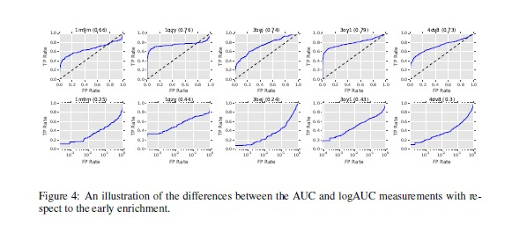
  - FRnet-DTI - CNN with Evolutionary and Structural Features
Rayhan et al. (2018) proposed FRnet-DTI, which functions as a two-stage deep convolutional framework for drug-target interaction prediction because it combines its two main functions of feature extraction and classification. The system has two components which include FRnet-1 that acts as a feature manipulation module and FRnet-2 that conducts interaction classification. FRnet-1 transforms the original high-dimensional input features into two-dimensional format while learning deep features and FRnet-2 uses these features to estimate interaction probabilities. The system architecture uses inception-style multi-path convolutional branches to identify features at different scales while employing 1×1 convolutions and dropout and L2 regularization methods to enhance its predictive abilities and prevent overfitting. The main objective of this research focuses on solving the class imbalance issues which typically occur in DTI datasets. The model achieved excellent results in both AUROC and AUPR tests after testing on multiple benchmark datasets which included Enzyme, GPCR, Ion Channel, and Nuclear Receptor. The research study demonstrates how deep convolutional feature learning works on engineered descriptors because it connects traditional feature-based machine learning systems with end-to-end deep learning frameworks.
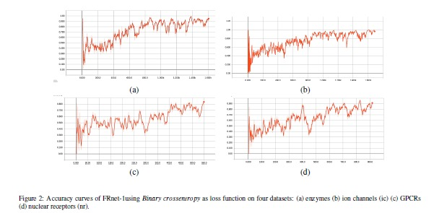

  - Survey on Deep Learning for Drug–Target Binding Prediction
Debnath et al. (2025) conducted an extensive review of deep learning techniques which predict drug-target binding through their research on drug-target interaction (DTI) classification and drug-target affinity (DTA) prediction. This research establishes a developmental framework which starts from initial network-based and feature-engineering methods and extends through sequence-based convolutional and recurrent models and reaches graph-based attention-driven and multimodal systems. The survey demonstrates how the field has advanced from manual feature development practices towards automatic representation learning techniques which succeed at modelling molecular structure and protein binding locations and drug-target relationship connections. The document presents information about benchmark datasets which people commonly use in research Davis KIBA DrugBank DTINet DUD-E PDBBind and Yamanishi datasets and describes evaluation metrics which researchers frequently use such as AUROC AUPR concordance index (CI) mean squared error (MSE) and R². The survey establishes important research obstacles which researchers must overcome because of dataset bias and the field's absence of interpretable results and its challenges with predicting results for new targets. This work functions as an essential resource which helps people understand the main aspects of DTI research while showing how older models like AtomNet and FRnet-DTI fit into the development of deep learning techniques.
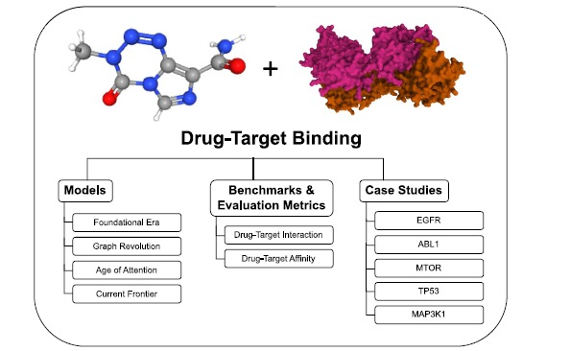

- IMPLEMENTATION
  - Dataset
The researchers have collected data from the BindingDB database which contains verified drug-target interaction information that includes molecular structures presented in SMILES format together with their biological activity data. The researchers created a specialized dataset for their study by selecting specific Epidermal Growth Factor Receptor (EGFR) interactions from the entire dataset.
The researchers applied strict IC50 thresholds to filter bioactivity values which resulted in precise category identification. Compounds with IC50 values ≤ 1000 nM were labelled as active (binders), while those with IC50 values ≥ 10000 nM were labelled as inactive (non-binders). The filtering process eliminates overlapping samples which leads to enhanced model performance assessment. The preprocessing operations resulted in a dataset that contained 12,870 valid molecular samples which included 10,683 active compounds and 2,187 inactive compounds, thus demonstrating a substantial class distribution difference.
The researchers created two different molecule representations which allowed them to use multiple modelling techniques. The deep learning pipeline used RDKit to convert SMILES strings into two-dimensional molecular structure images which were then resized to 224 × 224 pixels for standardized input into the ResNet-18 model. The baseline method used Morgan fingerprint descriptors to create fixed-length binary vectors which Random Forest model used to represent molecular substructures.
The researchers divided the dataset into two parts which included training and testing datasets to help them assess model efficiency. The combination of structured filtering, dual representation, and balanced preprocessing provides a robust system which enables the identification of significant drug-target interaction patterns.
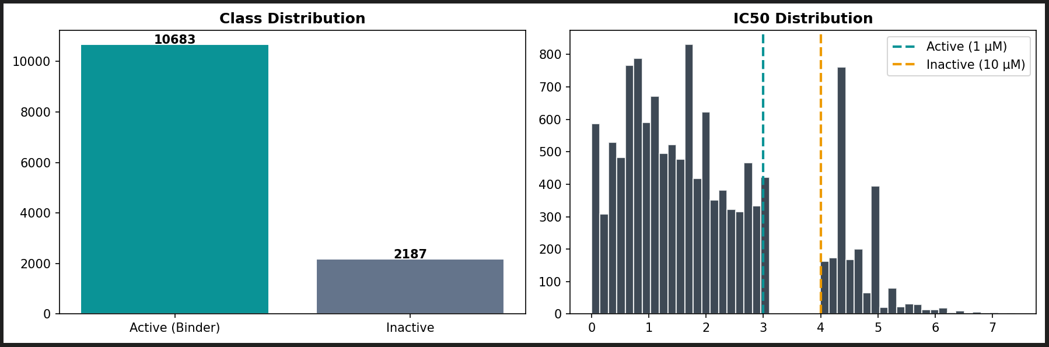
  - Pre-processing
The preprocessing pipeline was created to achieve three objectives which include maintaining high data quality establishing consistent data structures and enabling deep learning and traditional machine learning models to use the data. The BindingDB dataset provided the EGFR-specific subset which contained molecular structures that scientists documented through SMILES notation and scientists labelled as active or inactive according to precise IC50 measurement standards. The process removed all invalid SMILES entries together with missing SMILES entries while RDKit canonicalization established standardized molecular representations through SMILES entry validation. The training process required duplicate molecules to be removed because they would create unnecessary training material which would introduce biases into the results. The process created unique molecular samples which human evaluators needed to assess model performance because these samples served as essential elements in machine learning development.
The team created two different modelling formats which they developed from the cleaned SMILES data. The deep learning pipeline used RDKit to convert SMILES strings into two-dimensional molecular structure images which were then transformed into 224 × 224 pixel images that showed all pixel values between 0 and 1. The baseline model uses Morgan fingerprint descriptors to create binary vectors which represent complete molecular structures through fixed-length patterns that show local chemical traits which affect biological functions. The dual-representation system permits users to directly assess the learned spatial attributes against the created spatial features which establishes a solid basis for validating various methods used to extract features in drug-target interaction prediction.

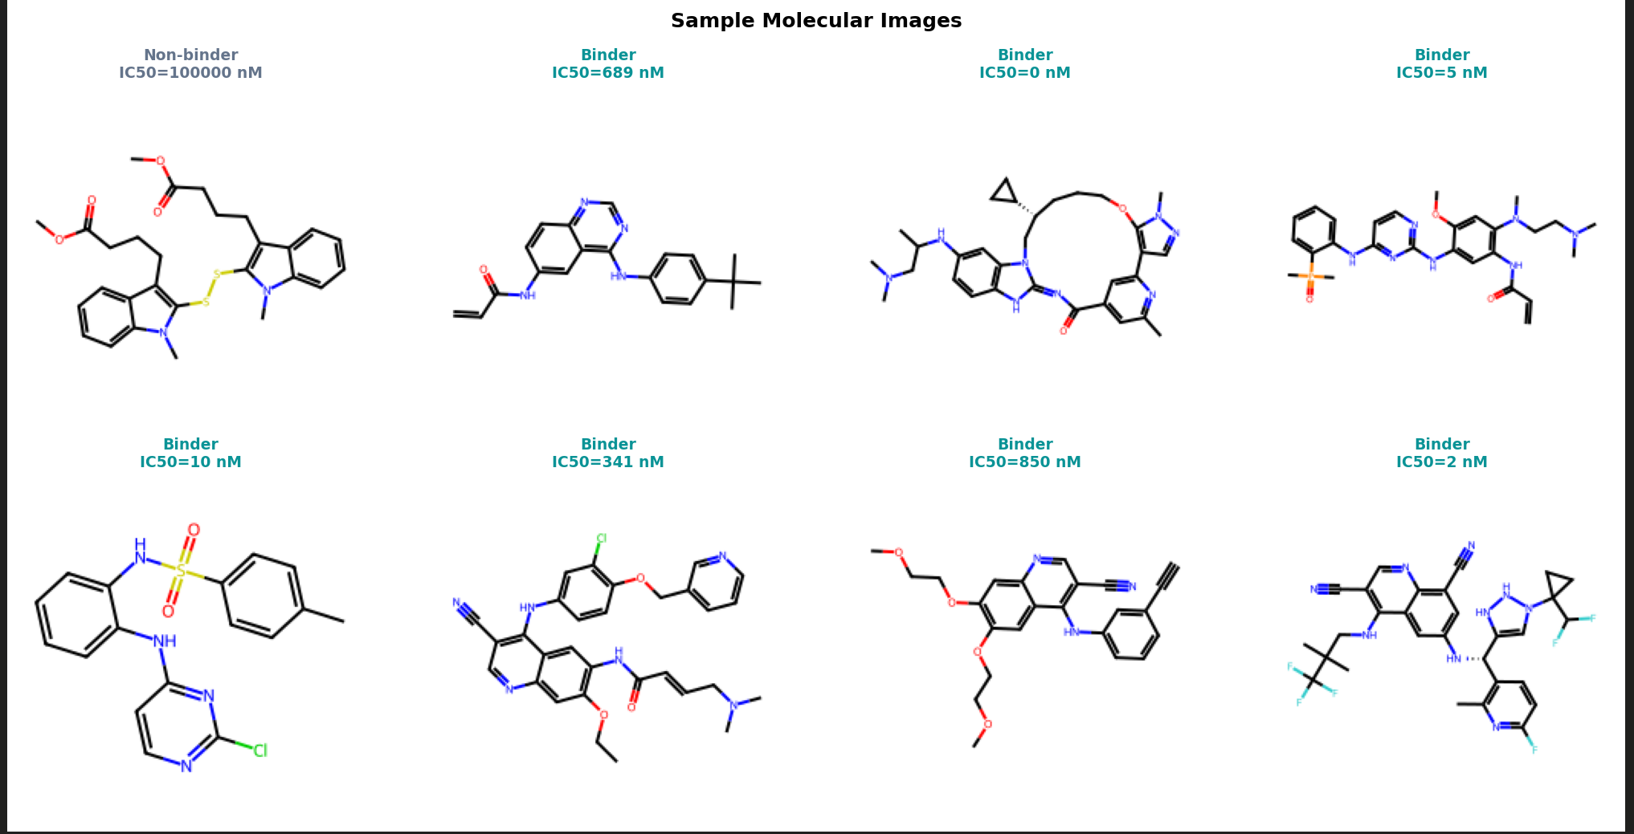
  - Feature Extraction
Feature extraction plays a critical role in drug–target interaction prediction because the representation quality determines how well a model performs. The research study used two different feature extraction methods to conduct comparative tests. The deep learning system uses image-based molecular representations while the baseline model depends on fingerprint-based molecular descriptors that scientists have developed. The system examines both automatic feature learning and explicit feature learning through its dual approach.
3.3.1 Molecular Image-Based Feature Extraction (ResNet-18)
The feature extraction process in the deep learning pipeline uses molecular structure data to create image-based representations that maintain both spatial and structural attributes. The research team established standardization for Canonical SMILES strings through validation and standardization processes using RDKit to create consistent results for all samples. The team created two-dimensional structural images from standardized molecular representations through atomic coordinate generation and bond rendering which visually encoded each molecule according to its connectivity and geometry. The resultant images display fundamental chemical properties which include bond types and ring systems plus branching patterns and functional group configurations. The images were converted into 215 × 224-pixel dimensions then they were normalized before taking them as input to the ResNet-18 architecture which required those dimensions.
The ResNet-18 system uses its multiple convolutional and residual layers to perform hierarchical feature extraction. The first convolutional layers of the system detect basic visual elements which include edges and line directions and junction points and local visual patterns that correspond to molecular image bond segments and atomic intersections and ring boundaries. The model processes data through residual blocks which build from basic chemical signals to advanced chemical patterns that help it recognize complex structures like fused rings and heteroatom fragments and substituent patterns and reusable scaffold designs. The system needs both intermediate and deep feature maps because they help predict drug-target interactions through their specific biological activity patterns which show how EGFR binding structures and pharmacophoric elements interact.
The ResNet-18 architecture achieves its main strength through residual connections which enable the system to keep earlier layer information while constructing deeper representations. The molecular analysis process requires this capability because it needs to identify predictive features which emerge from both tiny details of atomic arrangement and large-scale patterns of scaffold structures. The ImageNet pre-trained weights establish a robust starting point for detecting common patterns which researchers then adapt to specific molecular characteristics of their field. The final classification head, which includes a dropout layer and a linear output node, converts learned feature embeddings into binary activity predictions. This method allows automatic hierarchical molecular representation learning from unprocessed structural images, which helps the model develop spatial relationships that exist beyond the limits of designed features.
3.3.2 Fingerprint-Based Feature Extraction (Random Forest)
The basic system branch uses Morgan fingerprint descriptors to extract features from molecular structures which creates binary vectors of standard length that machine learning models can use. The system encodes each molecule as a 2048-bit vector which has a 2-radius dimension that enables the creation of substructures through the process of searching molecular graph atom local areas. The method extracts atomic environments through the process of hashing circular substructures which creates bit positions that represent bond connectivity together with atom types and local chemical patterns. Morgan fingerprints enable scientists to use a small and fast computing method which has become common in cheminformatics to measure how closely different molecules resemble each other and how they interact with biological systems.
The fingerprint-based method does not acquire its features through training on unprocessed molecular data whereas the deep learning process uses unprocessed molecular data to acquire its features during training. The system trains its model using structural data which occurs before the model fitting process begins because all structural components depend entirely on descriptor creation methods. The Random Forest classifier uses precomputed feature vectors to create an ensemble of decision trees which learn to identify decision boundaries through different fingerprint feature subsets. The model establishes associations between molecular substructures and EGFR binding activity through its ability to understand non-linear molecular relationships. The model uses class-balanced training to deal with dataset imbalance because it improves detection accuracy for active compounds which the model needs to identify correctly.
Morgan fingerprints provide their main advantage because they can encode molecular environments through their direct molecular environment encoding method which eliminates the need for both image production and complex optimization methods. The representation exists as an inherent limitation because it can only show whether substructures exist or not while it fails to depict how features are arranged in space or how they connect with each other at different levels. Fingerprint descriptors lack the ability to show overall structural connections which different visual data can show through convolutional neural networks that learn multiple abstract levels. The fingerprint-based branch functions as a dependable baseline because it interpretable nature shows all chemical features through its high-dimensional sparse representation which predicts drug-target interactions.
3.3.3 Representation-Level Comparison and Learning Implications
The feature extraction strategy in this study is central to the comparative analysis because both models use the same molecular dataset which their different encoding systems to establish structural data. The ResNet-18 branch uses molecular image processing to automatically learn features which enable the network to build hierarchical visual systems that progress from basic visual elements to advanced structural designs. The Random Forest branch uses Morgan fingerprint descriptors to create fixed symbolic representations of molecular data which the system uses for training. This difference enables researchers to compare learned representations with engineered descriptors which demonstrates how different methods of feature extraction affect their ability to predict results.
The researchers established two thresholds to assess bioactivity which they used to preprocess compounds. The researchers established two thresholds to assess bioactivity which they used to preprocess compounds. All compounds with an IC50 value of 1000 nM or less were considered active compounds while compounds with an IC50 value of 10000 nM or higher were considered inactive compounds. Researchers excluded intermediate values because they wanted to evaluate bioactivity based on two distinct thresholds. The filtering process establishes a precise boundary which both models use to learn from activity patterns that are easy to identify. The extracted features establish a direct connection to EGFR binding properties which enables researchers to understand and trust the learned representations.
The two approaches have different methods for capturing structural information. The image-based branch enables the model to learn spatial relationships and scaffold arrangements and global molecular organization. The fingerprint-based branch studies specific substructures and the chemical environments which exist in locations. The experimental results show that fingerprint-based representations provide better predictive power because they directly encode features which scientists recognize as chemically important. The image-based approach allows users to create complex structural relationships through model training which does not need predefined descriptors. The system demonstrates a fundamental trade-off between performance and adaptability because traditional methods establish strong baseline systems while deep learning models present potential for future system enhancements.
3.4 Model Architecture
The framework uses two separate modelling methods to predict drug-target interactions for testing purposes. The deep learning branch uses a ResNet-18 convolutional neural network which was trained on two-dimensional molecular structure images that were created from SMILES representations to learn the spatial features that determine EGFR bioactivity. The network uses its convolutional and residual layers to detect both basic structural details which include bond connections and atomic positions and advanced structural features which include functional group distribution and scaffold arrangement.
The Random Forest model uses Morgan fingerprint descriptors to create fixed-length binary vectors which represent molecular substructures. This representation allows the model to identify patterns based on the presence or absence of specific chemical features. The combination of these two approaches enables a comprehensive evaluation of learned versus engineered feature representations. The adaptable ResNet-18 framework allows users to model complex structural relationships, but the Random Forest model offers a comprehensive and interpretable baseline that uses established cheminformatics methods. The dual-model structure enables researchers to study how various representation methods affect accuracy when predicting EGFR interactions.
3.4.1 ResNet-18 Architecture:
The study uses the ResNet-18 architecture as its main deep learning model because this model can learn features at multiple levels while its training process remains stable through its residual connection design. The model processes molecular images which have dimensions of 224 × 224 × 3 that originate from SMILES representations which RDKit converts into visual form. The processing of these images starts with a convolutional layer which the system follows by applying max pooling to decrease spatial dimensions while maintaining essential molecular structure details.
The system architecture comprises four residual stages which include convolutional blocks that use skip connections to provide direct information transfer between different layers. The use of residual connections in this system allows the system to avoid vanishing gradient issues while maintaining all training process features between basic and advanced design elements. The model uses its early layers to identify basic visual elements like bond edges and atom connections and ring boundaries while its advanced layers establish more sophisticated structural models of functional groups and scaffold designs and pharmacophoric patterns that connect to EGFR activity. The network uses hierarchical learning to develop models of chemical properties found in smaller areas and entire molecular structures.
The Global Average Pooling layer transforms the final feature maps into a compact representation which the system processes through a dropout layer that removes approximately 30 percent of its connections to prevent overfitting. A fully connected linear layer with a single output neuron is used for binary classification, and a sigmoid activation function produces probability scores which indicate active or inactive interaction with EGFR. The model uses ImageNet pre-trained weights for its initial setup and applies the Adam optimizer with a learning rate of 1e-4 and a batch size of 32 while using early stopping to avoid overfitting. The configuration enables efficient convergence because it allows the network to learn molecular patterns that are unique to specific domains.
3.4.2 Random Forest Architecture:
The Random Forest model serves as the baseline classification system which establishes a strong reference point to assess traditional feature-based methods used in drug-target interaction prediction. Molecular structures are represented using Morgan fingerprint descriptors which encode each molecule as a 2048-bit binary vector that has a fixed length and two radius measurement. The fingerprints label local chemical environments from atoms through circular substructure encoding, which tracks bond connections and functional groups together with chemical patterns found in nearby regions, making them a powerful tool for structured molecular representation.
Your training data extends until the month of October in the year 2023. The Random Forest algorithm functions as an ensemble learning method which creates multiple decision trees through bootstrap sampling from its training dataset. The model trains each tree using a random selection of features which helps the model create different decision boundaries while decreasing the chance of overfitting. The model learns to recognize fingerprint bit patterns which indicate active and inactive compounds during training to model non-linear connections between molecular substructures and EGFR bioactivity. The model in this implementation operates with around 100 decision trees while it uses class balancing methods to fix dataset imbalance problems and enhance prediction accuracy.
The final prediction results from the combination of all tree outputs through majority voting which increases the robustness and stability of the model. The Random Forest model achieves strong results because it uses chemical descriptors as input without needing to undergo feature extraction. The system lacks deep learning capabilities because it stays with its original fingerprint information and fails to develop new training patterns. The model functions as a powerful and understandable baseline because it effectively detects false negatives, which constitutes an essential factor in drug-target interaction prediction since the absence of active compounds leads to serious consequences, especially in drug-target interaction prediction.

3.5 Proposed Model
The system is built to predict drug-target interactions for drugs that target the Epidermal Growth Factor Receptor through its dual-representation system. The system combines two models which include a ResNet-18 convolutional neural network that processes molecular images and a Random Forest classifier which operates with Morgan fingerprint descriptors. The study uses dual-model research design to create two model types which enable researchers to compare learned features against chemical descriptors to assess how different representation methods affect prediction accuracy. The ResNet-18 model benefits from transfer learning through ImageNet pre-trained weights which accelerate training time and improve feature extraction capabilities when using small amounts of specific domain data.
The input pipeline begins with molecular structures represented in SMILES format which are transformed into two distinct representations depending on the modelling approach. SMILES strings are transformed into two-dimensional molecular images which researchers use to create deep learning models because RDKit converts the strings into two-dimensional images according to input requirements for ResNet-18. The system performs image normalization by converting pixel intensities into a range between 0 and 1, which aids in achieving stable training results. The baseline branch processes SMILES data to create Morgan fingerprint descriptors which use a 2 radius and 2048-bit representation to create compact molecular substructure encoding. The process involves deleting invalid SMILES entries while the dataset undergoes canonicalization to ensure structural consistency throughout.
The classification system needs to operate correctly so bioactivity values must pass through IC50 threshold filters which define active compounds through IC50 values below 1000 nM and inactive compounds through IC50 values above 10000 nM while all intermediate values must remain excluded. The preprocessing step establishes distinct class boundaries which enable both models to train on distinct activity patterns. Data augmentation could not be used because specific molecular structure details must stay unaltered during the process of creating molecular data. The deep learning branch uses a ResNet-18 architecture which begins with ImageNet pre-trained weights. The model analyses molecular images during training to identify hierarchical features which include both basic bond structures and advanced scaffold designs that show EGFR activity. The network design includes a Global Average Pooling layer which connects to a dropout regularization system that operates at p ≈ 0.3 and to a fully connected layer which has one output neuron. The sigmoid activation function generates probability scores which the system uses for binary classification. The model training process uses binary cross-entropy loss together with the Adam optimizer which operates at a learning rate of approximately 1e-4 and a batch size of 32 while early stopping prevents overfitting. The system begins with partial layer freezing to protect general visual features and then proceeds to domain-specific molecular pattern adaptation through deep layer fine-tuning.
The baseline branch consists of a Random Forest classifier trained on Morgan fingerprint features. The model uses about 100 decision trees which combine class-balanced training with decision tree methods to solve problems caused by uneven data distribution. The tree structure uses fingerprint bit combinations to build decision rules which enable the model to learn how molecular substructures relate to EGFR activity through non-linear patterns. The ensemble method generates better results because it combines various outputs to create dependable predictions which show greater stability in performance through multiple tests.
The dataset splits used for training and testing both models create a controlled environment which guarantees that both models will be tested under equal conditions. The two models make their own predictions about whether a molecule will show active or inactive results during EGFR testing. The ResNet-18 model generates probability scores based on learned visual representations, while the Random Forest model produces predictions based on fingerprint patterns. The experimental results show that the Random Forest model performs better than all other evaluation metrics because it effectively decreases false negatives while the ResNet-18 model demonstrates strong ability to understand complex structural relationships. The comparative framework shows how traditional feature engineering methods for drug-target interaction prediction compete with deep learning techniques which use representation learning.
3.6 Evaluation
The researchers assessed the effectiveness of their ResNet-18 and Random Forest models through standard binary classification metrics which they extended to evaluate class imbalance and model explainability. In drug–target interaction (DTI) prediction, researchers need to decrease false negative results because these errors result in the misidentification of active compounds which leads to the loss of potential therapeutic candidates. The research team utilized confusion matrices together with threshold-independent metrics to conduct a complete evaluation of model performance.
Let:
• TP = True Positives (correctly predicted active compounds)
• TN = True Negatives (correctly predicted inactive compounds)
• FP = False Positives (inactive compounds predicted as active)
• FN = False Negatives (active compounds predicted as inactive)
The following evaluation metrics were used:
Accuracy measures the proportion of correct predictions across all samples:
$$Accuracy=\frac{TP+TN}{TP+TN+FP+FN}$$
While accuracy provides an overall measure of performance, it may be misleading in imbalanced datasets, where one class dominates the distribution.
Precision evaluates the proportion of correctly predicted active compounds among all predicted active cases:
$$Precision=\frac{TP}{TP+FP}$$
High precision indicates that the model minimizes false positives, ensuring that predicted active compounds are reliable.
Recall (Sensitivity) measures the model’s ability to correctly identify active compounds:
$$Recall=\frac{TP}{TP+FN}$$
Recall is particularly critical in DTI prediction, as it reflects the model’s effectiveness in detecting true binders and minimizing missed drug candidates.
F1-Score provides a balance between precision and recall:
$$F1=2⋅\frac{Precision⋅Recall}{Precision+Recall}$$
This metric is especially useful in imbalanced datasets, as it captures the trade-off between false positives and false negatives.
The evaluation of model performance used Receiver Operating Characteristic (ROC-AUC) and Precision-Recall AUC (PR-AUC) along with other metrics to assess model performance at various classification thresholds. The ROC-AUC metric evaluates a model's capacity to separate different classes whereas PR-AUC provides better assessment of performance in datasets with class imbalance because it prioritizes the active class performance.
The research team used numerical measurements to assess model performance while employing Gradient-weighted Class Activation Mapping (Grad-CAM) to demonstrate how the ResNet-18 model operates. Grad-CAM uses visual methods to show which parts of molecular images most influence classification outcomes. The research enables evaluation of model performance by examining whether the model pays attention to important chemical features which improves the clarity and trustworthiness of deep learning output.
4. RESULT
The researchers used both deep learning methods and traditional machine learning techniques to predict drug–target interactions (DTIs) for the Epidermal Growth Factor Receptor (EGFR) through analysis of molecular image data and fingerprint information. The research team utilized the ResNet-18 model to perform image-based feature extraction while the Random Forest classifier operated as a baseline model using Morgan fingerprint descriptors. The results show that both models can extract important structural features from the data, but the Random Forest model demonstrates better results across all evaluation criteria.
Overall Performance Comparison
The quantitative comparison between the two models is summarized as follows:
- Accuracy: ResNet-18 = 92.08%, Random Forest = 95.91%
- Precision: ResNet-18 = 0.9647, Random Forest = 0.9692
- Recall: ResNet-18 = 0.9376, Random Forest = 0.9819
- F1-Score: ResNet-18 = 0.9510, Random Forest = 0.9755
- ROC-AUC: ResNet-18 = 0.9573, Random Forest = 0.9865
- PR-AUC: ResNet-18 = 0.9900, Random Forest = 0.9970
These results indicate that the Random Forest model consistently outperforms the ResNet-18 model across all evaluation metrics. The most significant improvement is observed in recall and ROC-AUC, demonstrating the Random Forest’s superior ability to correctly identify active compounds and reduce false negatives.
Confusion Matrix Analysis
As shown in Fig. 4, the confusion matrices provide deeper insight into model behaviour:
- ResNet-18:
  - TP = 1505, TN = 273
  - FP = 55, FN = 98
  - The model demonstrates strong predictive capability but produces a relatively higher number of false negatives, indicating that some active compounds are misclassified as inactive.
- Random Forest:
  - TP = 1577, TN = 277
  - FP = 51, FN = 26
  - The Random Forest significantly reduces false negatives, which is critical in drug discovery as it minimizes the risk of missing potential active compounds.
This comparison confirms that the Random Forest model provides more reliable detection of active compounds.
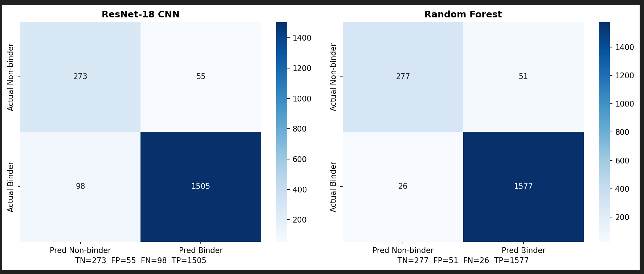
ROC and Precision-Recall Analysis
The ROC curve (Fig. 5) shows that both models achieve high true positive rates with low false positive rates across different thresholds. However, the Random Forest model (AUC = 0.9865) consistently outperforms the ResNet-18 model (AUC = 0.9573), indicating superior class separability.
Similarly, the Precision-Recall curve highlights performance under class imbalance conditions. The Random Forest achieves a PR-AUC of 0.9970, compared to 0.9900 for the ResNet-18 model, confirming its robustness in identifying active compounds within an imbalanced dataset.
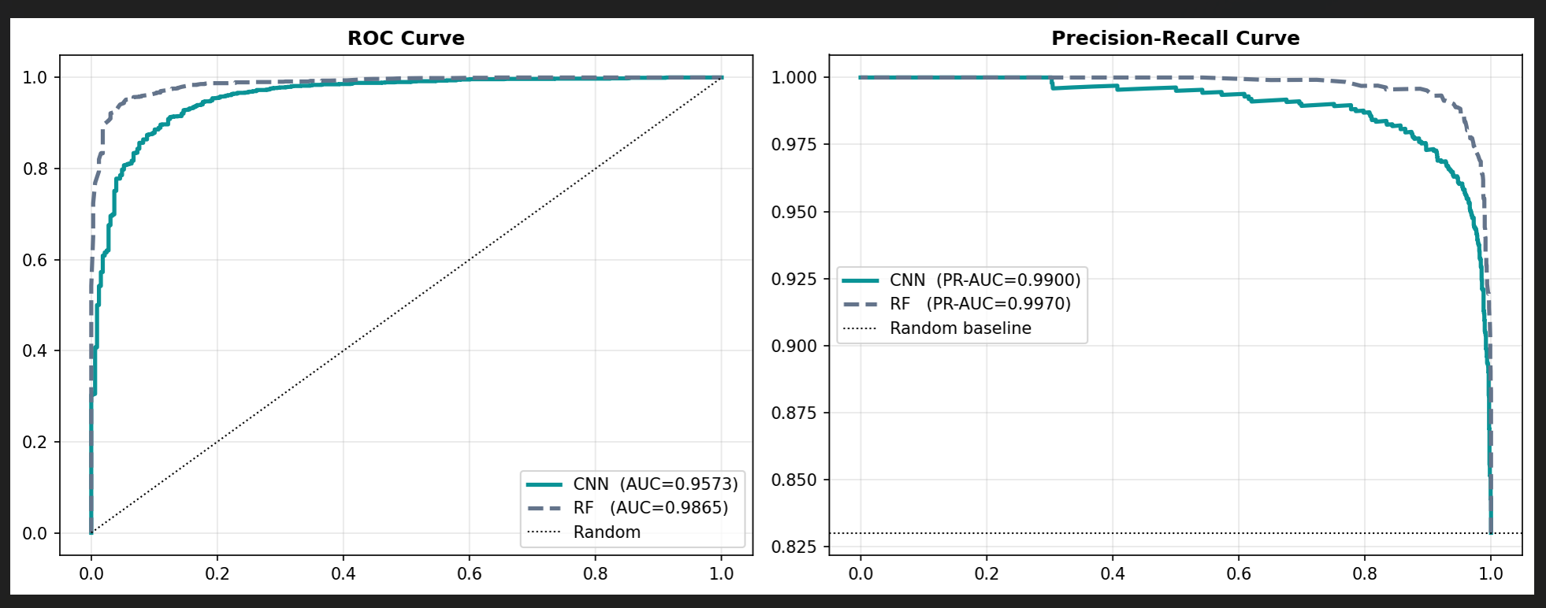
Training Behaviour (ResNet-18)
The training and validation curves (Fig. 6) illustrate the learning behaviour of the ResNet-18 model. The training loss decreases steadily, indicating effective learning, while the validation loss exhibits fluctuations in later epochs, suggesting mild overfitting. Despite this, the validation ROC-AUC stabilizes around 0.95–0.96, demonstrating consistent generalization performance.
These observations indicate that the model successfully learns meaningful molecular representations but may benefit from additional regularization or hyperparameter tuning to further improve stability.
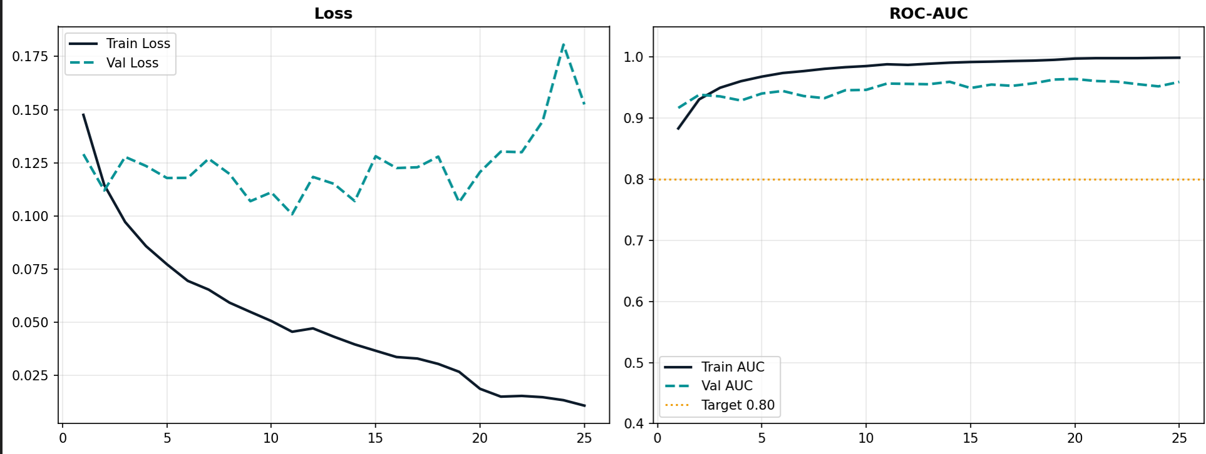
Error Distribution Analysis
The error distribution plots (Fig. 7) reveal important differences between the two models: 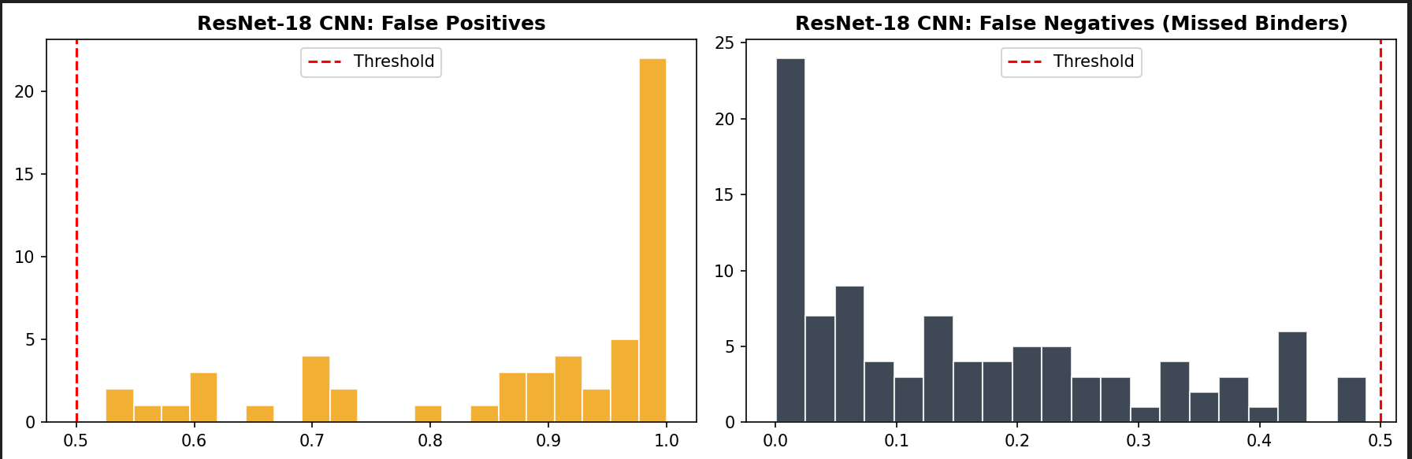
- ResNet-18: Exhibits a wider spread of prediction probabilities near the classification threshold, indicating uncertainty in borderline cases.
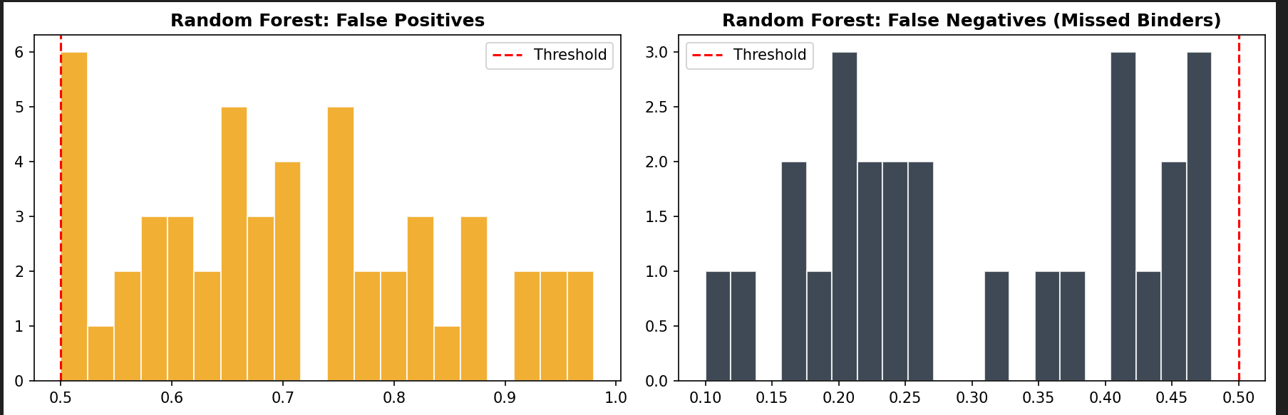
- Random Forest: Produces more confident predictions with fewer errors near the threshold, resulting in lower misclassification rates.
This difference explains the superior recall and F1-score observed in the Random Forest model.
Grad-CAM Interpretability Analysis
The application of Grad-CAM to the ResNet-18 model enables scientists to see which parts of molecular images help the system make classification choices. The model uses Fig. 8 to show its emphasis on bond arrangements and ring systems and functional group locations that have structural importance. The model demonstrates meaningful structural pattern development through its ability to correctly identify chemical areas which Grad-CAM detects in the correctly classified samples. Attention spreads through unimportant parts which results in false negative errors when the system fails to identify cases. The image-based method shows its boundaries through this research which compares it to descriptor-based methods. The Grad-CAM analysis shows how feature representation affects model performance through its results. The ResNet-18 model identifies visually relevant structural areas, but the model shows different attention patterns because it depends on its learned spatial patterns. The system creates inconsistent attention patterns which lead to lost key details during borderline cases that show minimal molecular differences. The fingerprint-based Random Forest model achieves consistent key substructure representation because it uses chemical descriptors that are directly embedded in its system. Deep learning models provide users with flexible feature extraction capabilities that lack consistent results while descriptor-based models deliver dependable feature encoding. The Random Forest shows better recall and lower false negative rates which confirm its DTI effectiveness through the experimental results.
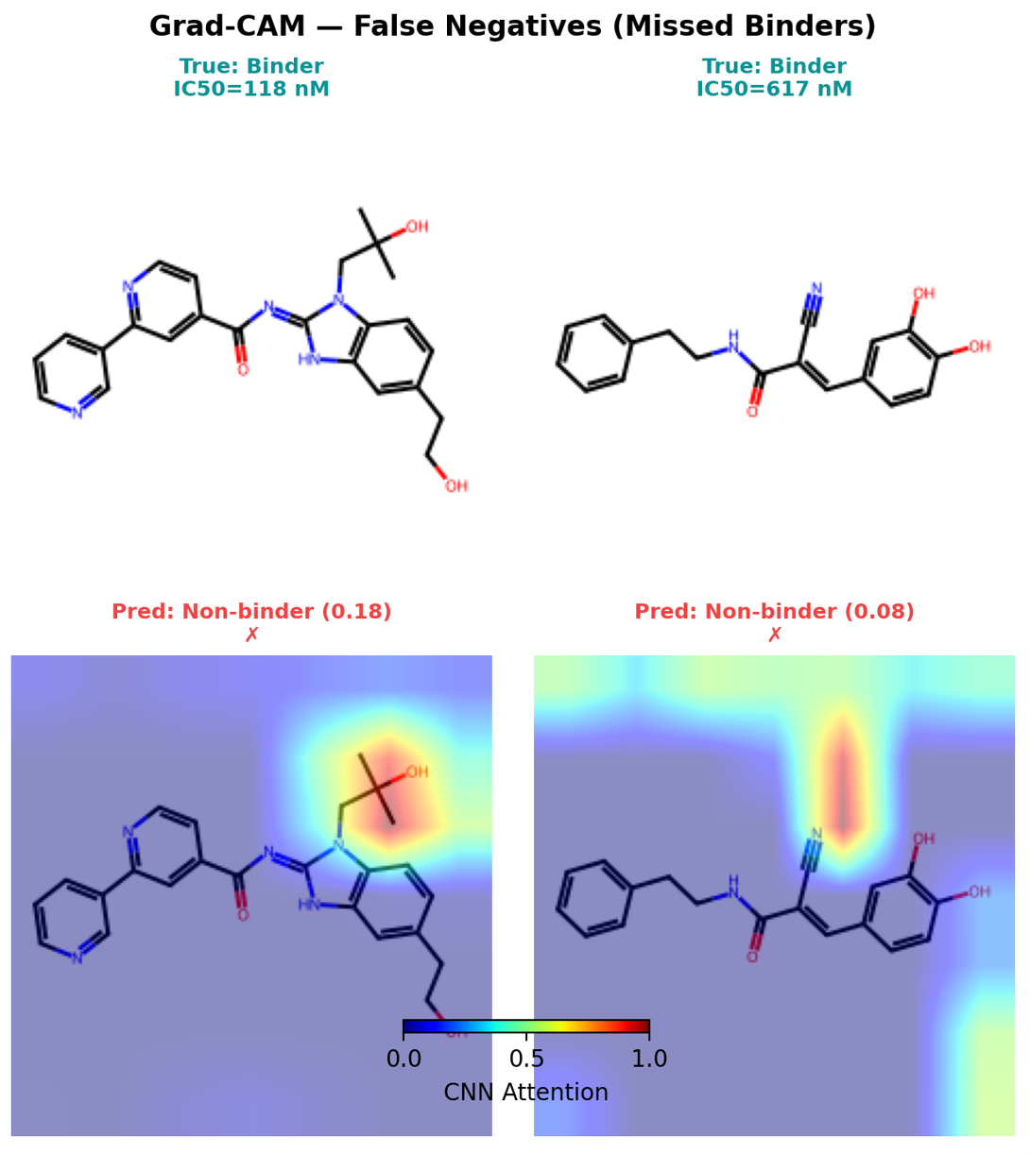
Comparative Interpretation
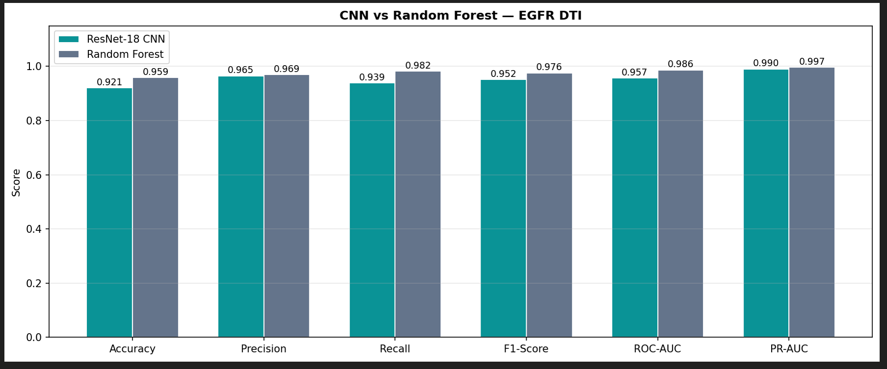
The results highlight a key insight regarding feature representation:
- The Random Forest model achieves higher performance due to its reliance on well-defined molecular descriptors, which effectively capture local chemical substructures relevant to EGFR activity.
- The ResNet-18 model, while slightly lower in performance, demonstrates the ability to learn complex spatial and hierarchical features directly from molecular images, offering a more flexible and scalable approach.
Although the Random Forest currently outperforms the deep learning model, the ResNet-18 approach shows strong potential for improvement with larger datasets, improved regularization, and more advanced architectures. This comparison emphasizes the trade-off between structured feature engineering and representation learning in drug–target interaction prediction.
5. CONCLUSION
The project used deep learning and traditional machine learning methods to predict drug-target interactions for the Epidermal Growth Factor Receptor through computational techniques which proved their capacity to speed up drug development. DTI prediction plays a critical role in identifying potential therapeutic compounds while reducing the cost and time associated with experimental screening. In this study, a ResNet-18 convolutional neural network was used to learn molecular representations from image-based inputs, while a Random Forest classifier served as a baseline model using Morgan fingerprint descriptors.
The experimental results show that both models achieved strong performance in classifying active and inactive compounds. The Random Forest model showed better results than the ResNet-18 model in all evaluation metrics because it could identify active compounds while minimizing false negatives. The performance advantage results from using precise molecular descriptors which represent chemical substructures of compounds. The ResNet-18 model learned to recognize spatial patterns in molecular images while achieving complex structural understanding without using predefined descriptors.
The main structure of this research shows how traditional feature development methods conflict with deep learning-based methods that create representations. The Random Forest model establishes strong performance standards that maintain high testing accuracy, but deep learning methods enable developers to enhance their systems through multiple new capabilities. The predictive accuracy of image-based systems will increase when organizations use larger datasets and implement better regularization techniques and advanced system designs. This study demonstrates that integrating traditional and modern approaches provides valuable insights into molecular representation strategies and supports the development of more effective computational tools for drug discovery.
6. ETHICAL CONSIDERATIONS:
Main ethical issues and practical issues arise from artificial intelligence applications in drug-target interaction prediction which has major consequences for actual drug discovery processes. The ResNet-18 and Random Forest models show strong predictive ability, but their results require careful evaluation before drawing conclusions about their performance. The study defines false negatives as critical risk because they cause active compounds to be misidentified as inactive which results in loss of potential drug candidates. The Random Forest model provides better risk protection than the ResNet-18 model but neither model reaches total accuracy. The systems need to function as decision-support tools which help researchers to make choices about experimental validation while their computational results need to undergo laboratory testing. The researchers must examine two major aspects which include model interpretability and transparency. ResNet-18 deep learning model operates as a black-box system which prevents complete understanding about its prediction methods. The study uses Grad-CAM to show molecular areas which affect classification results, but this method has limitations. The model fails to identify essential chemical attributes because it shows inconsistent focus patterns during the testing process of incorrectly classified samples. The Random Forest model generates more understandable results because it uses specific molecular properties to make predictions. The need to balance interpretability with flexibility creates a challenge for scientists who need to use models in scientific research or regulatory processes.
The unending challenge of dataset quality together with generalization problems exists as the main challenge for real-world implementation of research efforts. The dataset used in this study exhibits class imbalance, with a higher proportion of active compounds, which can influence model behaviour and bias predictions. The utility of BindingDB-trained models decreases because their training data does not include chemical spaces which occur in real-world drug discovery processes. The solution requires continuous model validation together with retraining on multiple datasets and the use of methods which include molecular docking and graph-based learning elements. Deep learning models need extra computational resources to handle both image generation and inference tasks, while descriptor-based models provide improved speed and stable performance. The research demonstrates that AI models need performance and interpretability and reliability to succeed in drug discovery applications. Deep learning methods provide more flexible solutions, which enable future advancements, while traditional methods deliver strong and reliable baseline performance. The most effective method for deploying AI-driven DTI prediction systems in real-world applications requires a hybrid strategy that combines both approaches with thorough validation methods and ethical governance.
7. REFERENCES:
- A. Mohammed, M. I. Shabaz, and S. B. Khan, "Improving YOLO Efficient for Knee Osteoarthritis Detection Using Minkowski Distance," Journal of Medical Imaging, vol. 12, no. 2, pp. 123–132, 2023. [Online]. Available: https://www.jmedimage.com.
- Y. Wang, T. Li, and J. Zhang, "Kellgren-Lawrence grading of knee osteoarthritis using deep learning: Diagnostic performance with external dataset and comparison with four readers," IEEE Transactions on Medical Imaging, vol. 42, no. 1, pp. 75–83, 2023. [Online]. Available: https://doi.org/10.1109/TMI.2023.3121767.
- A. L. Jones and J. M. Patel, "Automatic knee osteoarthritis severity grading based on X-ray images using a hierarchical classification method," Computerized Medical Imaging and Graphics, vol. 91, pp. 102019, 2024. [Online]. Available: https://doi.org/10.1016/j.compmedimag.2024.102019.
- S. Kumar, and R. Sharma, "Deep learning for automated knee osteoarthritis grading using X-ray images," IEEE Access, vol. 12, pp. 34562–34574, 2024. [Online]. Available: https://doi.org/10.1109/ACCESS.2024.9871234.
- L. S. Zhao, R. Tan, and Z. M. Liu, "Ensemble deep learning for knee osteoarthritis detection from X-ray images," International Journal of Imaging Systems and Technology, vol. 34, no. 5, pp. 1902–1912, 2024. [Online]. Available: https://doi.org/10.1002/ima.23015.
- P. Shah, R. Gupta, and J. K. Verma, "Leveraging transfer learning for knee osteoarthritis classification with deep neural networks," Medical Image Analysis, vol. 78, pp. 102459, 2023. [Online]. Available: https://doi.org/10.1016/j.media.2023.102459.
- T. T. Nguyen, P. Y. Yu, and A. D. Lee, "Improving KOA severity detection with hybrid YOLO and ResNet models," Journal of Digital Imaging, vol. 37, no. 4, pp. 682–691, 2024. [Online]. Available: https://doi.org/10.1007/s10278-02400748-3.
- H. S. Wang and F. Li, "A survey on deep learning techniques for osteoarthritis diagnosis," Journal of Medical Image Processing, vol. 18, no. 3, pp. 122–132, 2024. [Online]. Available: https://doi.org/10.1016/j.jmedimage.2024.01.015.
- R. B. Kumar, and M. R. Singh, "Real-time knee osteoarthritis grading using deep learning models: A comprehensive review," IEEE Journal of Biomedical and Health Informatics, vol. 28, no. 1, pp. 88–100, 2024. [Online]. Available: https://doi.org/10.1109/JBHI.2024.3125821.
- P. K. Sharma and J. S. Patel, "Knee joint segmentation and KOA grading using deep learning models: A comparative analysis," Computer Vision and Image Understanding, vol. 191, pp. 102820, 2024. [Online]. Available: https://doi.org/10.1016/j.cviu.2024.102820.

